Posted 11/14/2011 at 11:00 pm by JAV

Municipal Building Committee

Agenda
Old Library, Fireplace Room
Thursday, November 17, 2011
7:30 AM

Approve Minutes

Introductions
LLB
DTI
MBC

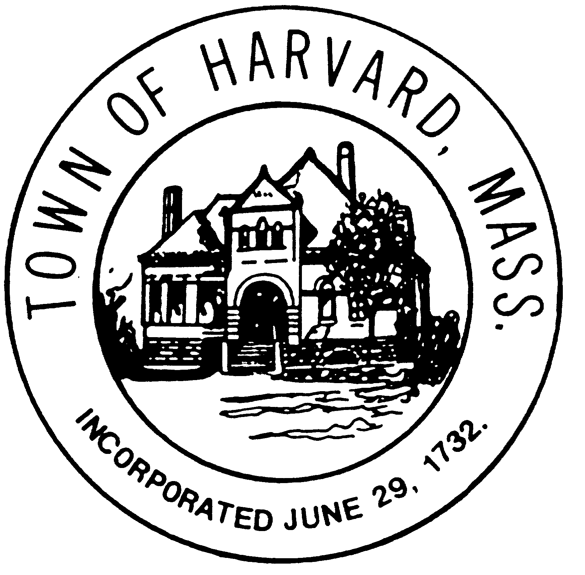
Discussion of schedule and budget
Meeting times
Key milestones
Communications
Other items need to complete a schedule and budget for schematic design

Agenda for next meeting

